Name: Brian Guadron
Date: 11/12/2026
Module 4.2 Assignment – MySQL Install

MySQL database connection

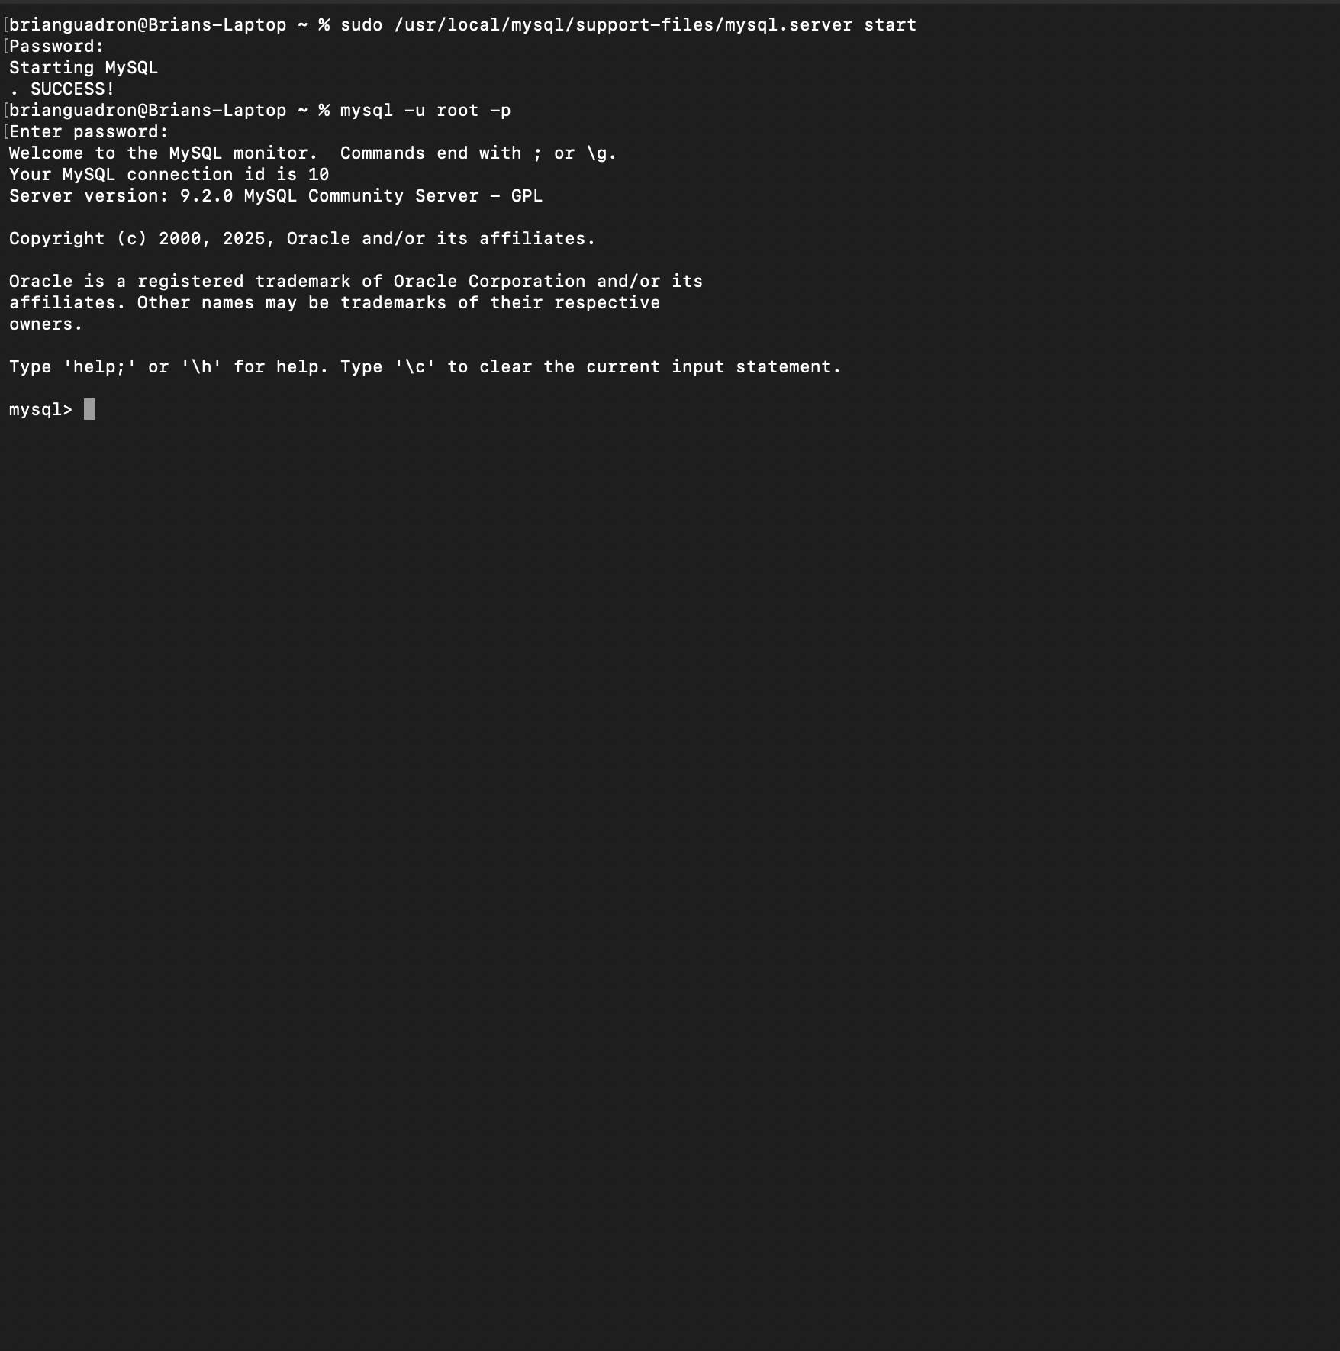

Created the database named movies – ran Show Databases command
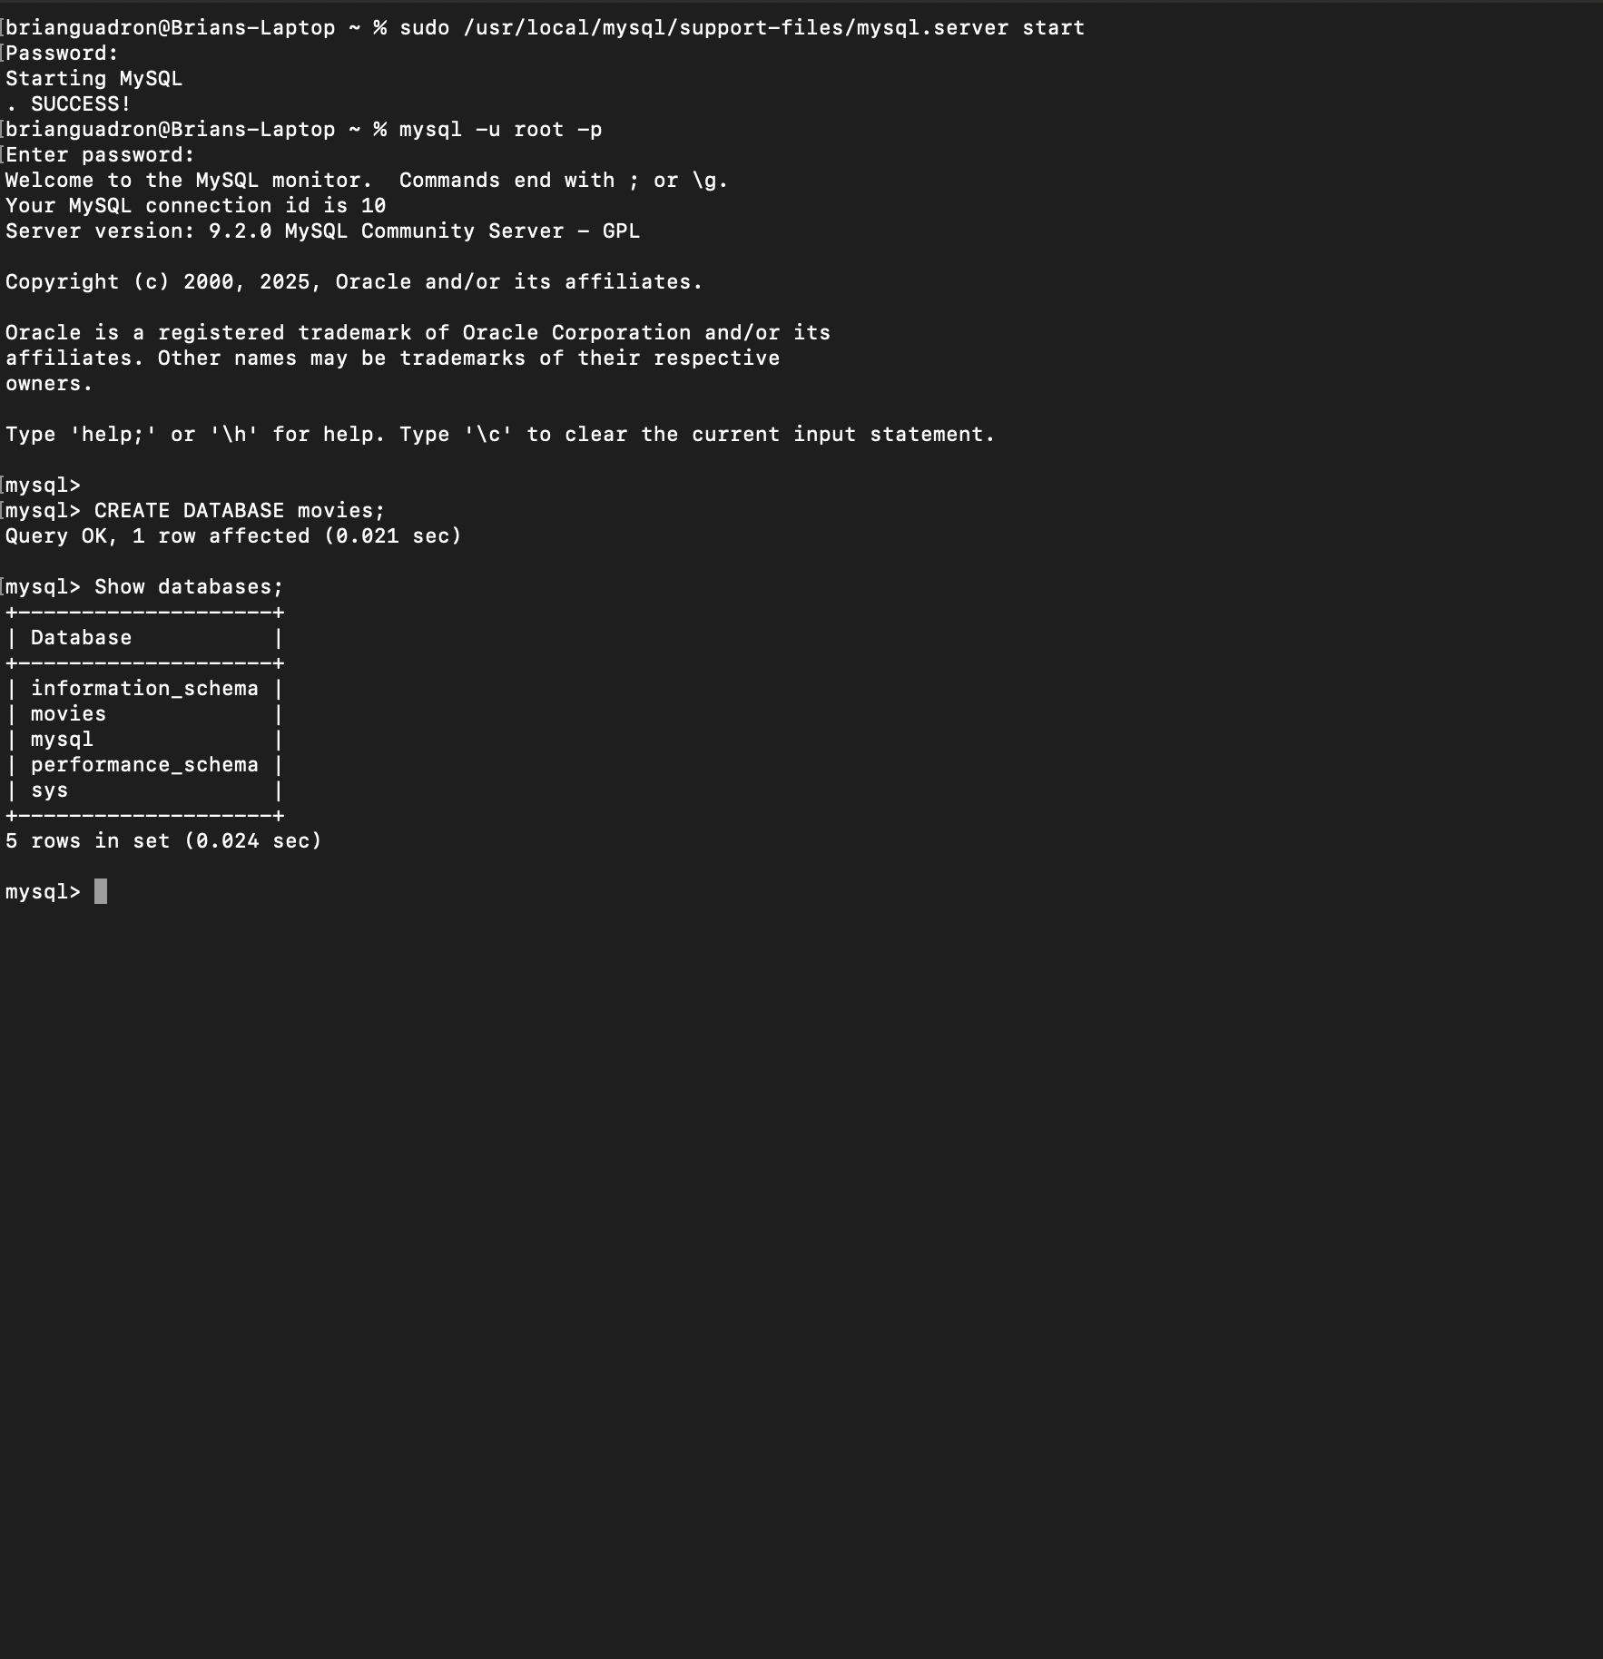

The three functions I selected from the W3Schools are LENGTH(), TRIM(), and REPLACE().

- LENGTH() function – This function can be used when the user need to count the number of character in a string. It is a very helpful function if you wanted to check the character count of each movie title on a table.
SELECT LENGTH(‘The Departed’) As Movie_Tile_Length;

Alias - Movie_Tile_Length
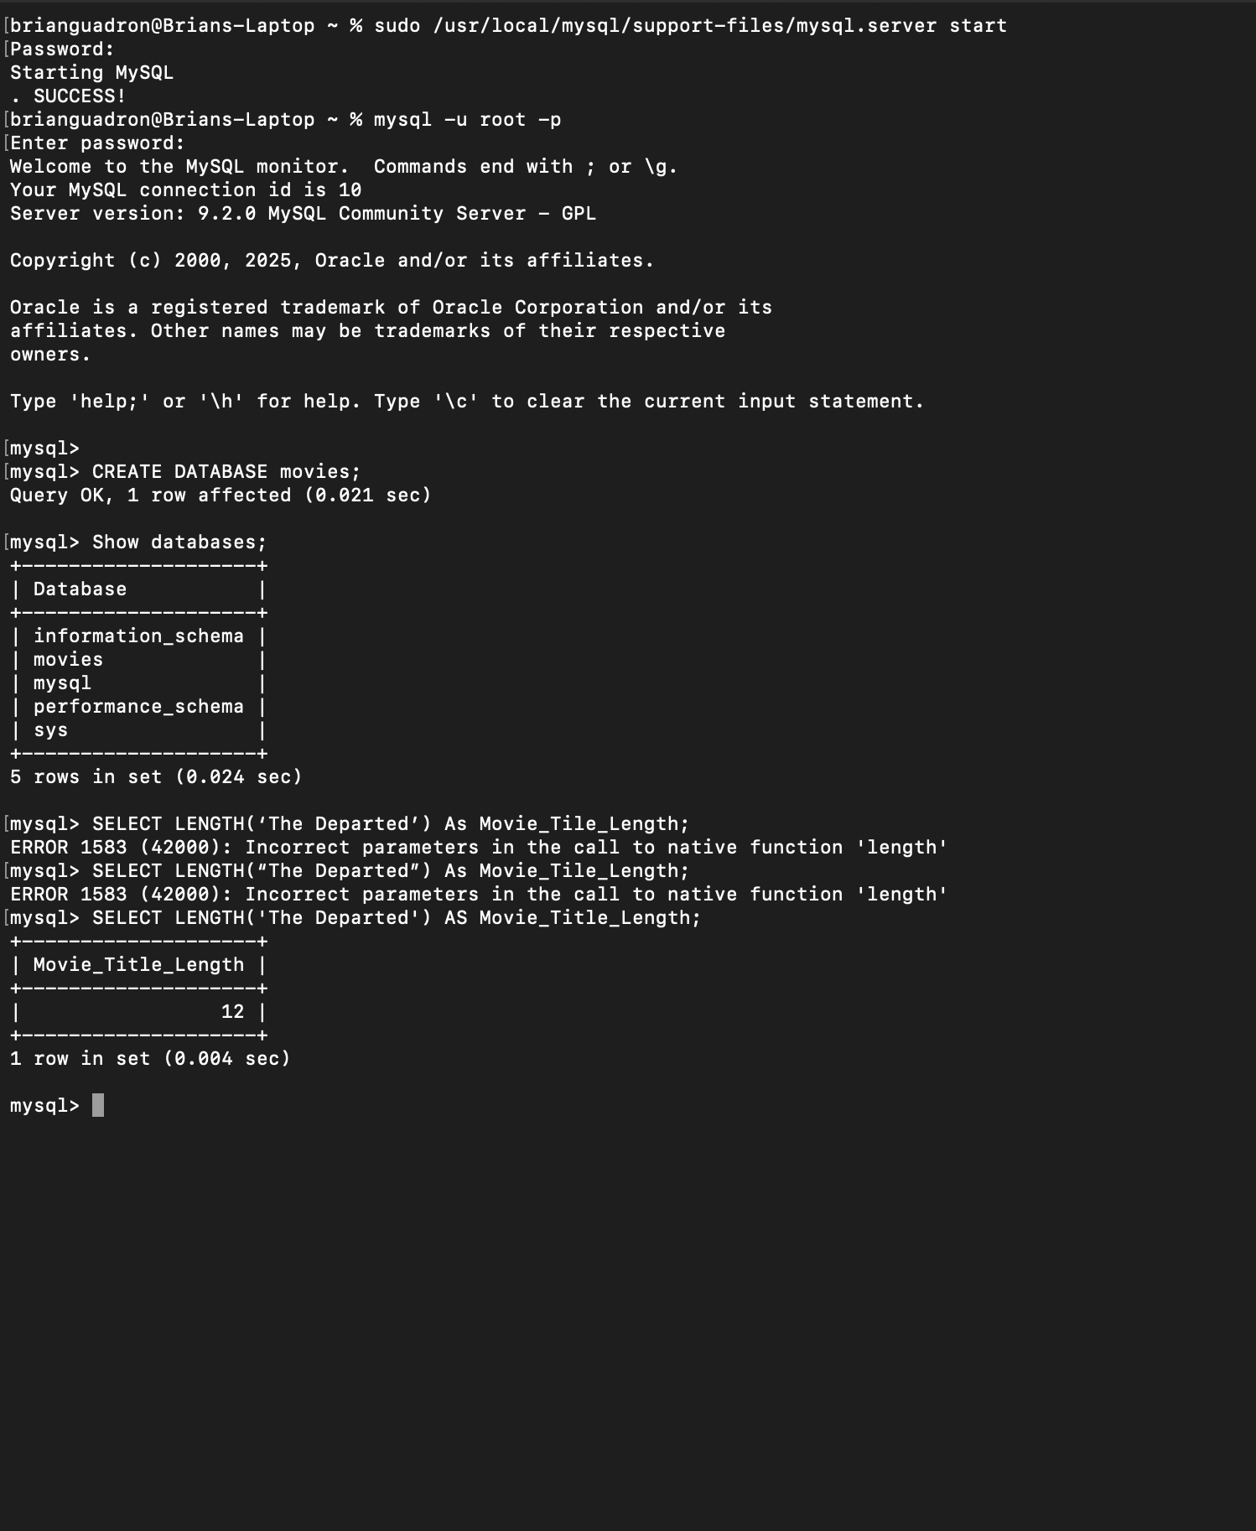

- TRIM() function – This function can be used to remove the unwanted leading and trailing spaces from a string. It is a very helpful function if you want to remove the accidental whitespace from the string.
SELECT TRIM(‘ The Departed ’) As Trimmed_Movie_Tile;
Alias - Trimmed_Movie_Tile
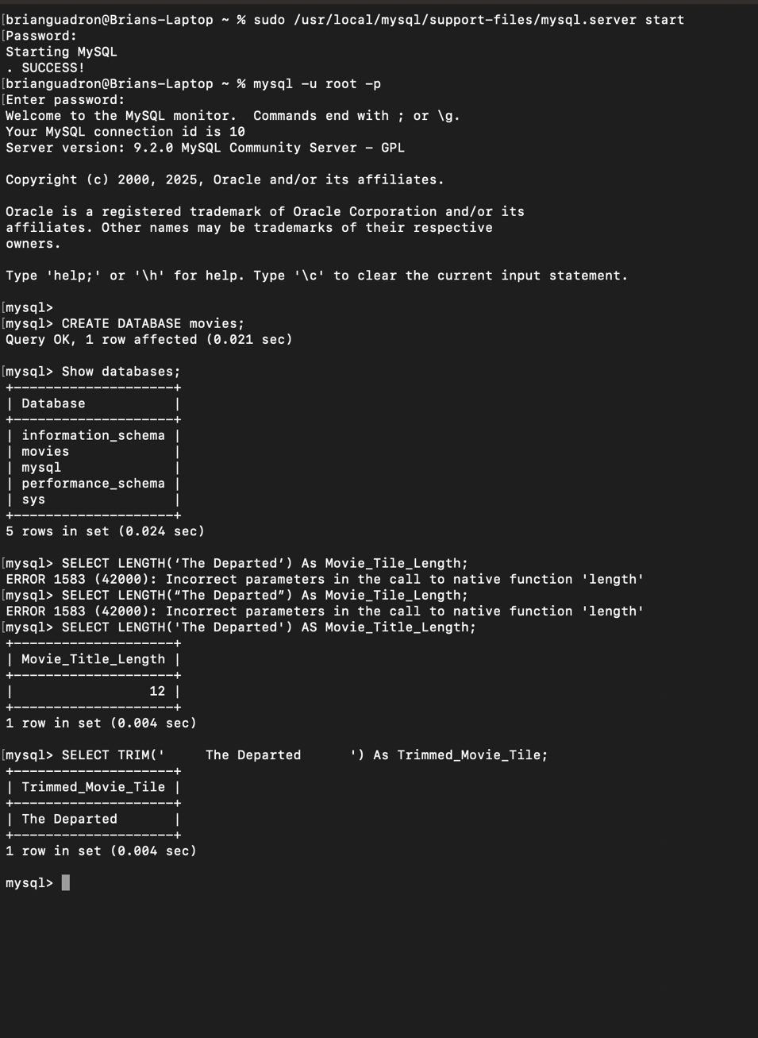

REPLACE() function – This function can be used to search for a specified substring and replaces all occurrences of it with the new substring. It is a very helpful function if you want to replace and display phone number without the dashes.

SELECT REPLACE(‘ 703-318-9900 ’, ‘-‘, ‘’) As Updated_Phone_Number;
Alias - Updated_Phone_Number;


